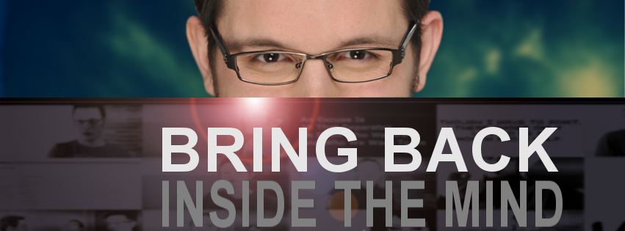

Lighting
(3) 1k Par 64 Lamps. $35/lamp x 3 = $105
(3) 1k Par 64 Bulbs. $29.95/bulb x 3 = $89.95

(2) 500w Par 56 Lamps. $24.99/lamp x 2 = $49.98
(2) 500w Par 56 Bulbs. $29.95/bulb x 2 = $59.90

(1) 250w Pro Light = $224.88

(2) ceiling fluorescent. $20.77 x 2 =$41.54

(1) 6,500k Led Studio Light = $299

(1) 550w 3 point flow light kit = $1,299

Gels CTO = $2
CTB = $2
Diffusion = $18.90
Neutral Density = $5.89

Total Cost for Lighting = $2,198.23

Camera Rigs
Manfrotto 504 HD tripod = $1,035

Kesslar Kflex dolly = $1,565.95

Kesslar Cineslider = $1,699.95

Kesslar Pocket Dolly = $1,095.95

Kesslar Pocket Jib = $1,199.95

Kc lite 8.0 = $399.95

ElektraDRIVE bundle with Oracle Controller = $1,315.95

Total Cost for Rigging = $8,312.70

Cameras/Lenses/HardDrives
BlackMagic Cinemacamera = $2,995

Samsung 1TB 830 Series SSD (storage space) = $1,058

Lenses
Canon Ef 17-55 =$1,059

tokina 11-16 2.8 = $739

Canon 70-200 2.8 = $1,199.99

Prime Canon 15mm 1.4 = $609.99

Prime Canon 20mm = $489

Total Cost For Cameras/Lenses = $8,149.98

Microphones
Rode Ntg 3 Pro ShotGun Mic Kit = $1,277.95

Sennheiser Ew112 Wireless Lav = $629.95

Total Costs for Microphones = $1907.90

Studio Space
2,500sq ft space for more involved shoots = $1,250/mo or $15,000/year

Misc
Portable Monitor for Camera = $384

Website Redesign = $4,000

Motion Graphics Broadcast Package = $4,000

Editor(s) = $20,000

Animator = $10,000

Vocus Marketing Software = $10,000

Computer = $4,000

Rewards Budget (tablets, ipods, SaaS subscriptions for members) = $5,000

Total Cost of Misc = $57,384

Total Cost of Production = $92,952.81

+ 7% Indiegogo fees = $99,955.81

(the remaining $44.19 will add to the bacon fund)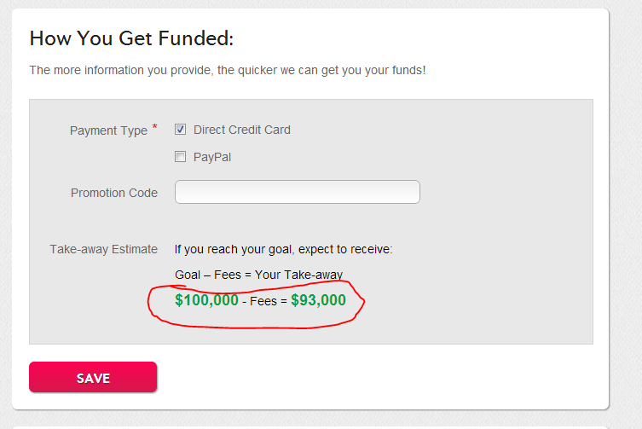

To see the kind of standard that we’re trying to bring the show to. Check out http://youtube.com/filmriot
It might not look like much, but the subtle differences in the production make a huge difference on the overall viewing experience.

