Family Fish Farms
Company lntroduction
A Green Urban Aquaponics Farming Business Model


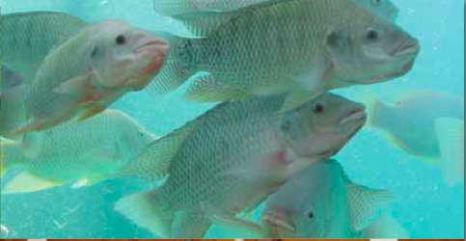
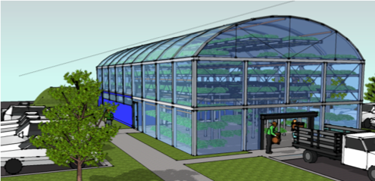
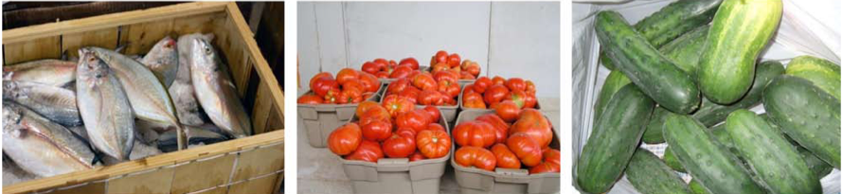
Family Fish Farms, Inc.
717 Lawrence Street, NE Washington, DC 20017
div. MicroVenture Support

We Grow fresh food, Stop Pollution, Conserve Clean Water, Provide Decent Jobs and Make a Healthy Profit.
Family Fish Farms plans to revolutionize the growing trend in urban farming in America. Our system of aquaponics has several major advantages over present hydroponics methods. We not only grow vegetables without the need for fertilizer but we also breed tilapia wihout the need to airfreight it from Central America or China. Our products have superiour environmental and nutritional qualites, plus higher profitability. Urban farming is growing in popularity. It is now possible to produce high quality local food on a 12 month growing cycle. This locally grown food is better tasting, more nutritious and price competitive with traditionally grown produce. Hydroponically grown vegetables are available now in many markets and grocery stores are the visible indicators of this change.

Our company employs aquaponics, a combination of intensive aquaculture and hydroponics to grow different varieties of seafood and vegetables. Our business model includes distributive production with small local operating units. In consumer terms this means a wide choice of fresh local food options in both vegetables and seafood. The resulting diversity in product mix gives us the flexibility to be responsive to local and regional consumer demand.

The Problem We Solve - How to provide access to safe nutritious food, locally grown and available at a reasonable price, is the principal problem we solve. We will achieve wide spread distribution starting on a local level and then through standardized processes, and comprehensive training, achieve our corporate mission to meet local, regional, and eventually national consumer demand.

A Green and Profitable Business Model - Our Company dramatically increases the market acceptance and profitability of urban farming by adding fresh seafood to its product mix. Aquaponics is an extremely efficient and productive technology. It permits us to grow a large quantity of fresh healthy food in the limited space of an urban farm.

Aquaponics also solves a number of pressing environmental problems as well. It does this by eliminating the need for commercial fertilizer, drastically limiting clean water usage and the cost of fuel for transport. This significantly shrinks the carbon footprint of food production. For example the average head of lettuce travels 1, 500 miles to market. On a macro scale, we also present the real possibility for ending the need to annually airfreight a million pounds of Tilapia from Central America and China.

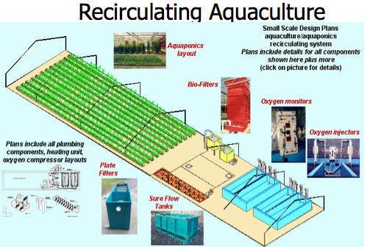

Marketing & Competitive Position
Family Fish Farms employs the next generation in Urban Farming. Our aquaponics production model is a superior technology. Unlike hydroponics, we produce a full spectrum of consumer food choices. Our hydroponic competitors have a natural limitation. Their farming method provides only half of human nutritional needs. A local food production system that grows vegetables only, with no protein, is leaving a significant portion of the US consumer food dollar on the table.

Pull Driven Value Chain - The growing market demand for quality, fresh, local food combined with the high cost of transportation faced by traditional farming methods makes our products highly competitive in the marketplace. Our production technology and resulting operating efficiencies allow us to make and maintain healthy profit margins in the face of global food imports, US agribiz, and our urban farming competition. As a local producer organization we also eliminate the jobber, or wholesale distributor from the value chain. Although our initial customers will be high-end retailers and restaurants, we are price competitive with imported products. Our fish and vegetables are actually fresh and sold within hours of harvesting. We can compete on price, but imported fish and centralized large-scale food producers will never be able to compete with us on freshness and quality. We see our value chain as being, “pull” driven. Our problems will not be centered around achieving marketing and sales goals, but on meeting customer demand.

In the overall market for fish and produce, we believe our business model is markedly superior to our producer competitors. We provide a full range of carbohydrate and protein consumer options. This coupled with our strategic rapid deployment capability provides credible evidence for the sustained rapid growth potential necessary to achieve our operating objectives.

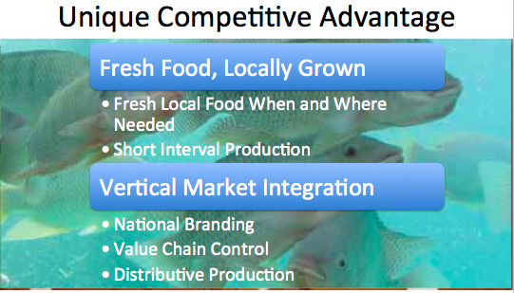
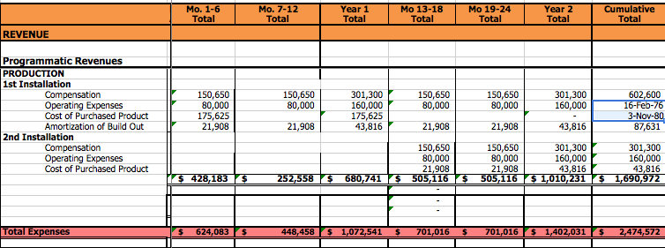
Marketing & Competitive Position - Family Fish Farms employs the next generation in Urban Farming. Our aquaponics production model is a superior technology. Unlike hydroponics, we produce a full spectrum of consumer food choices. Our hydroponic competitors have a natural limitation. Their farming method provides only half of human nutritional needs. A local food production system that grows vegetables only, with no protein, is leaving a significant portion of the US consumer food dollar on the table.

Pull Driven Value Chain - The growing market demand for quality, fresh, local food combined with the high cost of transportation faced by traditional farming methods makes our products highly competitive in the marketplace. Our production technology and resulting operating efficiencies allow us to make and maintain healthy profit margins in the face of global food imports, US agribiz, and our urban farming competition. As a local producer organization we also eliminate the jobber, or wholesale distributor from the value chain. Although our initial customers will be high-end retailers and restaurants, we are price competitive with imported products. Our fish and vegetables are actually fresh and sold within hours of harvesting. We can compete on price, but imported fish and centralized large-scale food producers will never be able to compete with us on freshness and quality. We see our value chain as being, “pull” driven. Our problems will not be centered around achieving marketing and sales goals, but on meeting customer demand.

In the overall market for fish and produce, we believe our business model is markedly superior to our producer competitors. We provide a full range of carbohydrate and protein consumer options. This coupled with our strategic rapid deployment capability provides credible evidence for the sustained rapid growth potential necessary to achieve our operating objectives

Financial Projections- Although our first unit will be profitable, we see rapid deployment as central to our overall success in the marketplace. Timing is key and we need to take advantage of the growing movement for local fresh food. Our projections are both realistic and conservative, still we achieve break even (operating revenue exceeds expenses) at the end of year one.
.

